Indian Classical Percussion Instrument Tabla Taal Classification using Fast Converging CNN

Nipun Sharma
ECE Department,PSOE
Presidency University
Bangalore, India
nipun.sharma@presidencyuniversity.in
Swati Sharma
CSE Department,PSCSE
Presidency University
Bangalore, India
swati.sharma@presidencyuniversity.in

Abstract—In the field of music study, retrieving information about music has become increasingly popular. Numerous applications in the realm of music have been created thanks to the development of neural networks' computational power and signal processing techniques. Based on the Taal names, we have suggested a Tabla Tala classification approach in this study. Eight Tabla Taals in all are taken into consideration for CNN training and validation. The experimentation is performed on an enhanced dataset with 561 audio files across 8 different Tabla Taals. For feature extraction, six additional sound characteristics are taken into account in addition to the conventional MFCC. Taal could be predicted with a validation accuracy of 95% accuracy and validation loss of around .22. By keeping the convolutional neural network simple, the computational effort is decreased. The results of the paper outperform the previous experimentation in the same filed. The results and the performance comparison with existing literature is presented in tabular form in the result sections for clearer comprehension.
Keywords—Indian classical instrument, tabla, taal, CNN, classification, music retrieval.

Introduction
The massive increase in the capacity of the efficient network infrastructure [1][2] for internet driven by state of the art hardware, antennas has resulted in exponential growth in AI, ML and interdisciplinary fields [3]. After the pandemic Deep Learning has impacted our daily lives in medical fields [4][5] for diagnosis [5]. The amalgamation of AI and ML in healthcare [6], unstructured formats [7], food availability prediction[8][9] and natural language processing [10] is a clear indication that possibilities and diversity is immense [11]. Blockchain has futher enhanced the availability of ML, AI and Deep Learning models with enhanced security [12][13]. The core of the blockchain intervention lies in cloud storage which is further enhanced by phenomenal high data rates [14][15] supported by 6G Thz antennas [16]. The literature suggests [17] that this evolving penetration of AI and ML[18] has also touched automation[19], IoT[20], learning and user experience[21]. An interdisciplinary example is the music domain. In this paper we discuss the application of Machine learning in classification of Tabla taals.
The Tabla was invented centuries ago and is the main accompanying instrument in the Indian Classical Music. Tabla is used in accompanying, by playing the rhythm cycles called as taalas. A taala is formed by some fixed amount of ‘bols’(Bols are the symbols that form a taala). Tabla, with several other percussive instruments such as Dholki, Dhol, Pakhwaj, Mridingam, etc are used in the Indian Classical Music for providing the rhythmic touch to the mix(song). A taala is formed by a fixed amount of bols for eg. 7, 8, 10, 12, 16 etc. Examples of taalas include Trital, Ektal, Rupak, Jhaptal, Addhatrital, etc. The research on tabla taal classification using neural networks offers several key insights and potential applications. It is a novel approach that Utilizes neural networks to recognize and categorize complex rhythmic patterns in Classical Indian music, specifically for tabla taals. The user-friendly interface implements a Graphical User Interface (GUI) for easy input of audio files and instant recognition results. It has found practical applications in assisting amateur tabla players in learning and practicing taals. It provides a valuable tool for instructors to assess and guide students.It enhances music analysis capabilities in the field of Classical Indian music. There is a potential for automation that opens up possibilities for automated identification of tabla taals, which could significantly impact the study and teaching of Classical Indian music. The technological advancements demonstrate the application of machine learning techniques in the realm of traditional music, bridging the gap between technology and cultural heritage. The research presented in [22] explores the classification of Classical Indian Music Tabla Taals using a combination of Feedforward Neural Networks (FNN) and Convolutional Neural Networks (CNN). This study focuses on recognizing widely known taals such as Addhatrital, Ektal, Rupak, Dadra, Deepchandi, Jhaptal, Trital, and Bhajani [1]. The mixed-methods approach employing both FNN and CNN enables efficient dissection and categorization of tabla taals, addressing the complex rhythms characteristic of Classical Indian music.
Interestingly, while [22] specifically addresses tabla taal classification, other papers in the context discuss various applications of neural networks for classification tasks in different domains. For instance, [23] explores ECG rhythm classification using artificial neural networks, while [24] focuses on brain cancer classification using MRI images. This demonstrates the versatility of neural network approaches in tackling diverse classification problems across multiple fields. Many other researchers have explored the viability of the machine learning in classifying the Indian ragas [25], string instruments [26], timbre and emotion detection [27] and instrument pitch [28] etc.

methodology

Dataset
In this section an in-depth analysis of tabla taalas and how are they visualized and complete understanding. The dataset consists of 8 folders and a file descriptor. There are 8 classes of taalas which are hand recorded by me and and classified as: Addhatrital, Bhajani, Dadra, Deepchandi, Ektal, Jhaptal, Rupak, Trital wavfiles consists all the .wav files under a same directory for easier access. Some prefer the files sorted, some under one hood. Table I shows the distribution of the wave files in the folder.
- data set count of tabla taals
Sr. No | Tabla Taal | Count of Wave Files
1 | Addhatrital | 78
2 | Bhajani | 72
3 | Dadra | 72
4 | Deepchandi | 60
5 | Ektal | 60
6 | Jhaptal | 60
7 | Rupak | 60
8 | Trital | 99
 | Total | 561

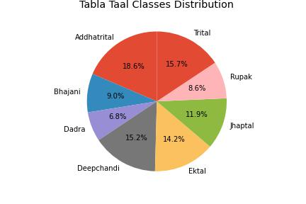
- Tabla Taal Classes Distribution

Preprocessing
The preprocessing of the data involves Exploratory Data Analysis (EDA) of the data files which are Tabla Taals in wav format. The Librosa package in python is used for extracting features. Librosa is the most versatile package for audio and music extraction in python that allows to extract the following features. 1. Chroma_stft 2. Root Mean Square (RMS) 3. Spectral Centroid 4. Spectral Bandwidth 5. Spectral Rolloff 6. Zero-Crossing Rate (ZCR) 7. Mel-frequency Cepstral Coefficients (MFCCs). All these features are more than enough to represent the Tabla Taal audio into numerical data. A spectrogram is generated by taking the average of these features. A visual representation provided by spectrogram is an important step in classification of Taals using sight. Fig.2 and Fig. 3 show the Time series and Fourier transforms of all the 8 Tabla Taals. A visual inspection reveals interesting observations about Taals, for example the Time series representation of Dadra taal depicts that the table strokes are discrete and the energy distribution is concentrated over strokes only.
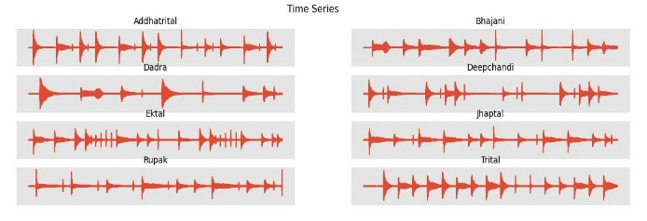
- Time Series analysis of the Table Taals
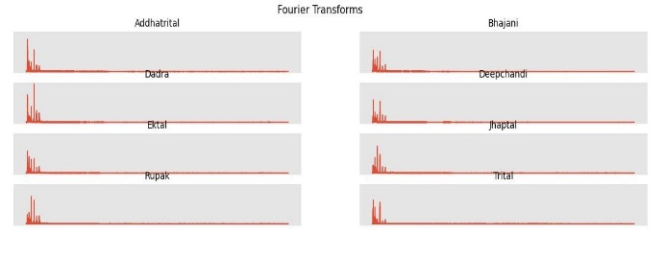
- Fourier Transform analysis of the Tabla Taals
Similarly the Fourier representation of the Taals depict that all Taals have different frequency components with different concentrated weights. The overall distribution of the frequency range for tabla taals is within the same bandwidth distinguishing it from other percussive instruments. Some of the Indian classical percussive instruments are very closely related like mridungam and dhola. The fourier represenattion of the Taals on different percussive instruments can be compared in the future study to classify the instrument itself. The preprocessing of data has resulted in 26 features which are named as [chroma_stft, rms, spectral_centroid, spectral_bandwidth, rolloff, zero_crossing_rate, mfcc1, mfcc2, mfcc3, mfcc4, mfcc5, mfcc6, mfcc7, mfcc8, mfcc9, mfcc10, mfcc11, mfcc12, mfcc13,mfcc14, mfcc15, mfcc16, mfcc17, mfcc18, mfcc19, mfcc20 ] with the target labelled as the tabla taal having eight classes as shown in Table.I . A brief discussion of these features is presented below. A chroma vector a 12-element feature vector of the relative energy of each pitch class in the signal and a typical chromagram of a random addhatrital is shown in Fig.4.
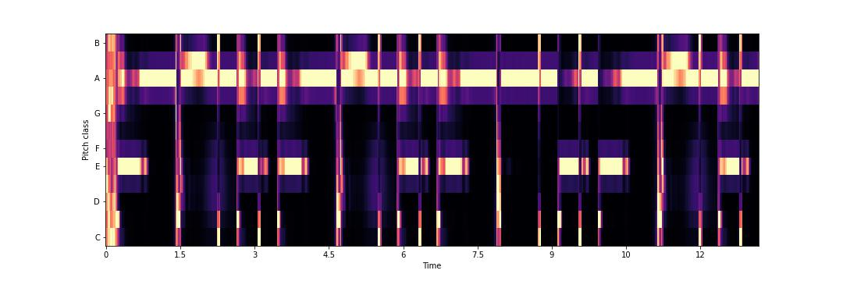
- Example of chromagram for addhatrital
The RMSE (root mean squared energy) of the signal, defined as
$$RMSE= \sqrt{\frac{1}{N}\sum_{n}{{\left|x(n)\right|}^{2}}}$$
where x(n) is a time signal.
The center of mass of the signal, e.g. the weighted mean of frequencies in the signal. Librosa has ability to graphical represent the center of mass of the audio signal using in-module functions and an example of center of mass of a random addhatrital is shown in Fig.5.
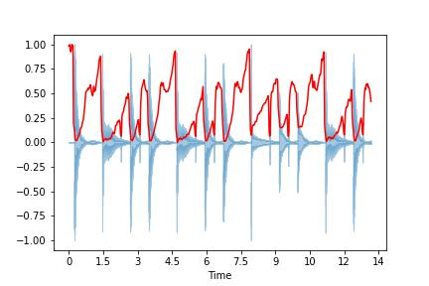
- Example of center of mass of addhatrital.
Another feature that Librosa can extract out of the audio signal is the order p spectral bandwidth is mathematically defined as
$$Order p spectral bandwidth= {(\sum_{k}{\left(S(k\right)}{\left(f\left(k\right)-f_{c}\right)}^{p})}^{\frac{1}{p}}$$

where S(k) is the spectral magnitude at frequency bin k, f(k) is the frequency at frequency bin k, and fc is the spectral centroid. The graphical representation of the order p spectral bandwidth of the addhatrital chosen is plotted as shown in Fig.6.
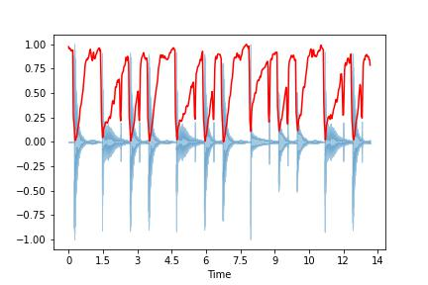
- Spectral roll off of addhatrital.
The next feature is spectral rolloff which is defined as the frequency below which a certain percentage of spectral energy lies. The zero crossing rate is the rate at which the signal changes sign (crosses y = 0).and it is depicted in Fig.7.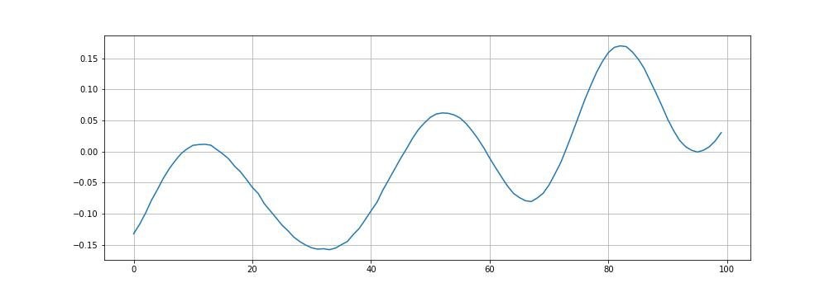
- Zero Crossing rate of addhatrital
The Mel-Frequency Cepstral Coefficients (MFCCs) shown in Fig.8 are a set of features which describe the shape of a spectral envelope.
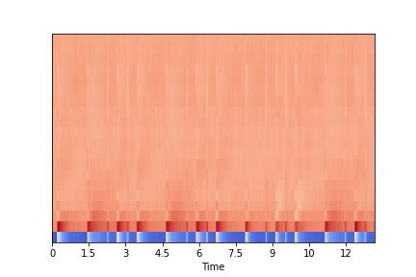
- MFCC of addhatrital

Model Training and Evaluation
The experimentation on the dataset is performed on a local i7 PC with 16 GB RAM with no additional graphics card. The code is written in python using multiple additional libraries like matplotlib, sklearn, librosa, tensorflow etc to achieve the final result.

Results and discussion
The post processed data has 26 features and a target. The target has a label Table taal. The CNN model is kept to be very simple deliberately to reduce computational power and increase convergence time. The CNN model has the following specifications as mentioned in the Table II
- data set count of tabla taals
Sr. No | Model Parameter | Value
1 | Loss | Categorical_crossentropy
2 | Optimizer | Adam
3 | Metric | Accuracy /Loss
4 | Validation split | 0.1
5 | Batch size | 10
6 | Epoch | 10
7 | No of hidden layers | 2

The results of the CNN layer with fastest possible convergence are extremely encouraging. The validation accuracy is 95% as shown in the Fig.9 The validation loss is reduced to .22.
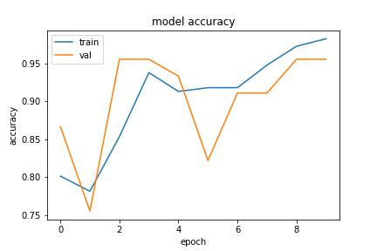
- Model Accuracy of the tabla taal classification
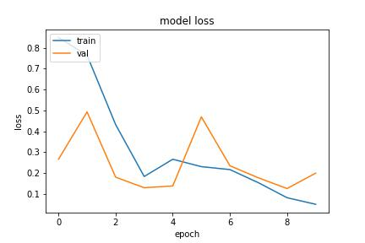
- Model Loss of the tabla taal classification
The model has outperformed the work done in the past in the many parameters listed in the Table III. The table clearly shows that the work has been able to outperform in each and every parameter of the study present in the literature.
- data set count of tabla taals
Parameter | Work Presented in [22] | Proposed Work
Convergence | Epochs = 30 | Epochs =10
Hidden Layer | 4 | 2
Dataset Size | 424 | 561
Validation Accuracy | ~81% | 95%
Validation Loss | ~.38 | .22

conclusion and future scope
The work presented in the paper may inspire further studies in applying neural networks to other aspects of Classical Indian music or to different musical traditions.It can thereby preserve cultural knowledge by digitizing and automating the recognition of tabla taals. This research contributes to the preservation and dissemination of Classical Indian musical knowledge and its interdisciplinary impact that combines elements of computer science, signal processing, and musicology, showcasing the potential for cross-disciplinary research in music technology. In conclusion, the research on tabla taal classification using neural networks presents a novel approach to recognizing and categorizing complex rhythmic patterns in Classical Indian music. The implementation of a Graphical User Interface (GUI) allows users to input audio files and receive instant recognition, making it a valuable tool for both amateur tabla players and instructors [1]. This system not only contributes to the field of music analysis but also opens up new possibilities for automated identification of tabla taals, potentially revolutionizing the way Classical Indian music is studied and taught.

References
- N. Kaur, N. Sharma, and N. Kumar, “RF Energy Harvesting and Storage System of Rectenna: A Review,” Indian J Sci Technol, vol. 11, no. 25, pp. 1–5, Jul. 2018, doi: 10.17485/ijst/2018/v11i25/114309.
- N. Sharma and A. Kaur, “Analysis of Metasurface Unit Cell Geometry on Wideband THz Antenna Design”, doi: 10.1109/AIC.2023.81.
- R. M. N, S. Vasant Nikam, M. Lakshmi Prasad, S. Sharma, S. Mukherjee, and P. Chandra Shaker Reddy, “An Automatic Error Recognition approach for Machine Translation Results based on Deep Learning”, doi: 10.1109/IC457434.2024.10486776.
- A. T. Somnathe, I. A. Tayubi, P. C. S. Reddy, N. Sharma, V. Sharma, and M. Yesubabu, “Brain Computer Interaction Framework for Speech and Motor Impairment Using Deep Learning,” Institute of Electrical and Electronics Engineers (IEEE), Mar. 2024, pp. 1008–1013. doi: 10.1109/peeic59336.2023.10450481.
- L. C. S. Reddy, R. Jayakarthik, A. Kiran, N. Sharma, S. Sharma, and P. C. S. Reddy, “An Uncertainty-Aware Deep Learning-Based Model for COVID-19 Diagnosis,” in 3rd IEEE International Conference on Mobile Networks and Wireless Communications, ICMNWC 2023, Institute of Electrical and Electronics Engineers Inc., 2023. doi: 10.1109/ICMNWC60182.2023.10435818.
- D. K. Yadav, N. Sharma, and J. M. Kudari, “An Effective Statistics Investigation for the Structured Healthcare using Reasonable Ensemble Machine Learning Systems,” in 2023 IEEE International Conference on ICT in Business Industry & Government (ICTBIG), IEEE, Dec. 2023, pp. 1–5. doi: 10.1109/ICTBIG59752.2023.10456190.
- A. Gadupudi, R. Yamini Rani, N. Sharma, J. Krishna Deshmukh, and P. Chandra Shaker Reddy, “An Adaptive Deep Learning Model for Crop Yield Prediction”, doi: 10.1109/IC457434.2024.10486733.
- S. Baskar, I. Nandhini, M. L. Prasad, T. Katale, N. Sharma, and P. C. S. Reddy, “An Accurate Prediction and Diagnosis of Alzheimer’s Disease using Deep Learning,” in Proceedings of NKCon 2023 - 2nd IEEE North Karnataka Subsection Flagship International Conference, Institute of Electrical and Electronics Engineers Inc., 2023. doi: 10.1109/NKCon59507.2023.10396132.
- P. C. Shaker Reddy, S. Nithyapriya, N. Sharma, S. Maheswari, B. Jayaram, and T. Katale, “A Novel Ensemble Deep Learning Framework for Breast Cancer Prediction,” in 2023 International Conference on Innovative Computing, Intelligent Communication and Smart Electrical Systems (ICSES), IEEE, Dec. 2023, pp. 1–6. doi: 10.1109/ICSES60034.2023.10465347.
- K. Gunavathy, A. Agarwal, and N. Sharma, “Unstructured Healthcare Statistics Exploration Consuming Modest Ensemble Machine Learning Methods,” in International Conference on Recent Advances in Science and Engineering Technology, ICRASET 2023, Institute of Electrical and Electronics Engineers Inc., 2023. doi: 10.1109/ICRASET59632.2023.10420014.
- A. Gadupudi, M. L. Prasad, S. Kedar Nadgaundi, P. C. Shaker Reddy, S. Sharma and N. Sharma, "A Deep Learning Framework For Human Disease Prediction Using Microbiome Data," 2024 International Conference on Integrated Circuits and Communication Systems (ICICACS), Raichur, India, 2024, pp. 1-6, doi: 10.1109/ICICACS60521.2024.10498711.
- N. Sharma and S. Sharma, “A Survey of Mythril, A Smart Contract Security Analysis Tool for EVM Bytecode,” Indian Journal of Natural Sciences, vol. 13, no. 75, pp. 51003–51010, 2022, [Online]. Available: https://www.researchgate.net/publication/366391033
- N. Sharma, S. Sharma, and A. Sindgi, “Solidity Smart Contract Vulnerabilities, Attack Scenarios, and Mitigation—A Survey,” 2023, pp. 901–910. doi: 10.1007/978-981-99-3485-0_71.
- N. Sharma and S. Sharma, “Empirical Analysis of Effect of Higher Order Harmonics on Guitar Chord Classification,” in Lecture Notes in Networks and Systems, Springer Science and Business Media Deutschland GmbH, 2023, pp. 647–656. doi: 10.1007/978-981-19-9638-2_56.
- Sharma, Nipun, and Swati Sharma. "Human-Interacted Computation System: A State of the Art in Music." Heterogenous Computational Intelligence in Internet of Things (2024): 1-17.
- Sharma, Nipun, and Swati Sharma. "Natural Language Processing A Study of State of the Art." AI-Centric Modeling and Analytics. CRC Press 91-111.
- Sharma, N., & Kaur, A. (2024). A systematic review of meta-surface based antennas for Thz applications. Radio Science, 59, e2024RS007980. https://doi.org/10.1029/2024RS007980
- Sharma, N., & Kaur, A. (2024). Optimization of Graphene-based Antenna using Metasurface for THz Applications using Ensemble Learning models. International Journal of Sensors, Wireless Communications and Control, 14. https://doi.org/10.2174/0122103279333623240911055915
- Tayubi, I.A., Prasad, M.L., Reddy, P.C.S., Sharma, S., Sharma, N., Sharma, V. (2024). A Lightweight Group Authentication Framework for Blockchain-Enabled IoT Network in Healthcare Systems. In: Nguyen, T.D.L., Dawson, M., Ngoc, L.A., Lam, K.Y. (eds) Proceedings of the International Conference on Intelligent Systems and Networks. ICISN 2024. Lecture Notes in Networks and Systems, vol 1077. Springer, Singapore. https://doi.org/10.1007/978-981-97-5504-2_31
- L. P. Mudarakola et al., “A Deep Learning Framework for IoT Lightweight Traffic Multi-classification: Smart-cities,” International Journal of Sensors, Wireless Communications and Control, vol. 14, no. 3, pp. 175–184, Sep. 2024, doi: 10.2174/0122103279292479240226111739.
- Sharma, S., Kumar, H. P., Goudanavar, N. P., & Sharma, N. Data Analytics–A Study of State of the Art in the Era of Digital Economy. Synergy of AI and Fintech in the Digital Gig Economy, 44-80.
- S. T. Patil, et al. 2024. Classification of Classical Indian Music Tabla Taals using Deep Learning. International Journal on Recent and Innovation Trends in Computing and Communication. 11, 9 (Jan. 2024), 3227–3232. DOI:https://doi.org/10.17762/ijritcc.v11i9.9513.
- A. Singha, S. Saravanan, J. Arun Pandian, and N. R. Rajalakshmi, “Deep Learning-Based Classification of Indian Classical Music Based on Raga,” Mar. 2023, vol. 12, pp. 1–7. doi: 10.1109/iscon57294.2023.10111985.
- S. N. Kakarwal and S. R. Chaudhary, “Analysis of Musical String Instruments using k-NN,” Oct. 2020, pp. 283–286. doi: 10.1109/icsidempc49020.2020.9299588.
- A. Anand, “Raga Identification Using Convolutional Neural Network,” Feb. 2019, vol. 1, pp. 1–6. doi: 10.1109/icaccp.2019.8882942.
- S. John, L. P. P, S. R. S, and M. S. Sinith, “Classification of Indian Classical Carnatic Music Based on Raga Using Deep Learning,” Dec. 2020, vol. 71, pp. 110–113. doi: 10.1109/raics51191.2020.9332482.
- M. Basu, S. Sanyal, A. Banerjee, S. Nag, K. Banerjee, and D. Ghosh, “Neural quantification of timbre and emotions from Indian Classical Music: A multifractal exploration,” Physica A: Statistical Mechanics and its Applications, vol. 624, p. 128937, Jun. 2023, doi: 10.1016/j.physa.2023.128937.
- A. Bhat, V. Mahesh, K. G. Krishnan, and V. K. Ananthapadmanabha, “Deep Learning Approach to Joint Identification of Instrument Pitch and Raga for Indian Classical Music,” springer, 2022, pp. 159–174. doi: 10.1007/978-3-031-18444-4_8.

